Abstract class in Java

An **abstract**class in Java is one that is declared with the abstract keyword. It may have both abstract and non-abstract methods(methods with bodies). An **abstract**is a **java modifier** applicable for **classes**and **methods** in java but***not for Variables***.

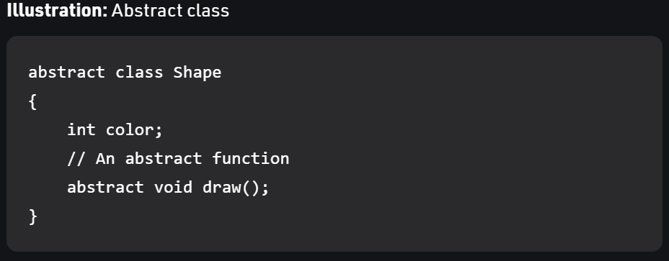

In java, the following some *important observations*about abstract classes are as follows:

1. An instance of an abstract class can not be created.
2. Constructors are allowed.
3. We can have an abstract class without any abstract method.
4. There can be a **final method** in abstract class but any abstract method in class(abstract class) can not be declared as final  or in simpler terms final method can not be abstract itself as it will yield an error: “Illegal combination of modifiers: abstract and final”
5. We can define static methods in an abstract class
6. We can use the **abstract keyword** for declaring ***top-level classes (Outer class) as well as inner classes*** as abstract
7. If a**class** contains at least **one abstract method**then compulsory should declare a class as abstract
8. If the**Child class** is unable to provide implementation to all abstract methods of the**Parent class**then we should declare that **Child class as abstract**so that the next level Child class should provide implementation to the remaining abstract method

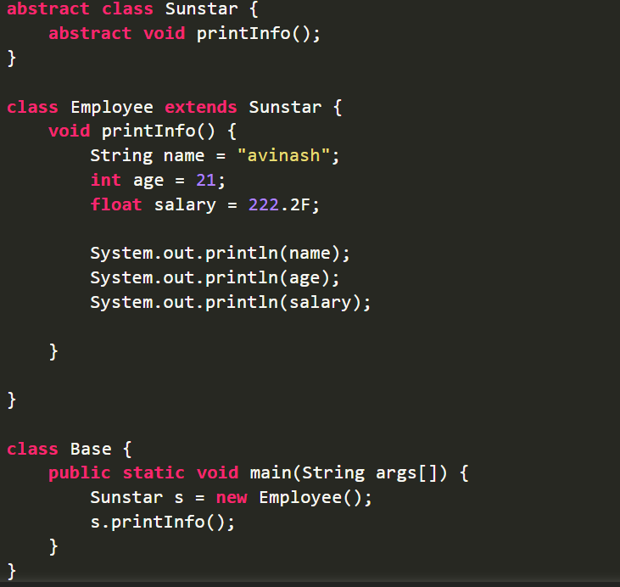



<https://www.scientecheasy.com/2021/02/abstract-class-interview-questions.html/>